

**KOLEJ PROFESIONAL MARA BERANANG**

**DIPLOMA IN COMPUTER SCIENCE**

|  |  |  |
| --- | --- | --- |
| **COURSE NAME** | **:** | **WEBSITE APPLICATION DEVELOPMENT** |
| **COURSE CODE** | **:** | **CSC2173** |
| **ACADEMIC SESSION** | **:** | **SESSION 1 2023/2024** |
| **TYPE OF ASSESSMENT** | **:** | **PRACTICAL TEST 1** |
| **DURATION** | **:** | **1.5 HOURS** |

**CLO 2: BUILD DYNAMIC WEBSITE BASED ON WEB FRAMEWORK.**

**INSTRUCTION TO CANDIDATES:**

1. Time allowed is **1.5 HOURS.**
2. Execute all tasks.
3. Submit Django project folder (compressed/zip) and a document containing the screenshot in MS Teams.

|  |  |
| --- | --- |
| **Section / Question No.** | **Marks** |
| **Part A** | **/3.5** |
| **Part B** | **/12.5** |
| **Part C** | **/24** |
| **Total** | **/40** |

|  |  |
| --- | --- |
| **Personal Details** | |
| **Name** |  |
| **I/D Number** |  |
| **Class** | **DCS 4 [A]** |
| **Lecturer** | **PUAN NURHANNANIE** |

### Overview

Tables shown below are part of Movie_Rental database.

Membership

|  |  |  |
| --- | --- | --- |
| membershipid (PK) | membershipname | emailaddress |
| M001 | Janet Jones | janet@google.com |
| M002 | Robert Phil | robert@yahoo.com |
| M003 | Elly Junior | elly@google.com |

Movie

|  |  |  |
| --- | --- | --- |
| movieid(PK) | movietitle | movieduration |
| V1 | The super mario bros | 3 |
| V2 | Elemental | 3 |
| V3 | Trolls 3 | 2 |

Records

|  |  |  |  |  |
| --- | --- | --- | --- | --- |
| rentalcode (PK) | membershipid(FK) | movieid (FK) | startdate | returndate |
| R1 | M001 | V1 | 2023-02-20 | 2023-02-25 |
| R2 | M002 | V1 | 2023-03-15 | 2023-03-20 |
| R3 | M001 | V2 | 2023-03-18 | 2023-03-23 |

### Software requirement: Visual Studio Code

### Language : Python



### Framework : Django

**Part A: Create a Django project (Task 1-3)**

* + 1. Create a django project name ‘yourstudentid_name’ for example: BCS2107001_Ahmad.
    2. A screenshot of a computer program

       Description automatically generatedCreate an application Rental



**Part B: Create database using Visual Studio Code. (Task 3-4)**

* + 1. **A screenshot of a computer program

       Description automatically generated**Add application in settings.py
    2. Create class based on the tables provided in overview above with appropriate:

1. Class name
2. Properties (data type, maximum number of character)
3. A computer screen with text and symbols

   Description automatically generatedA black screen with white text

   Description automatically generated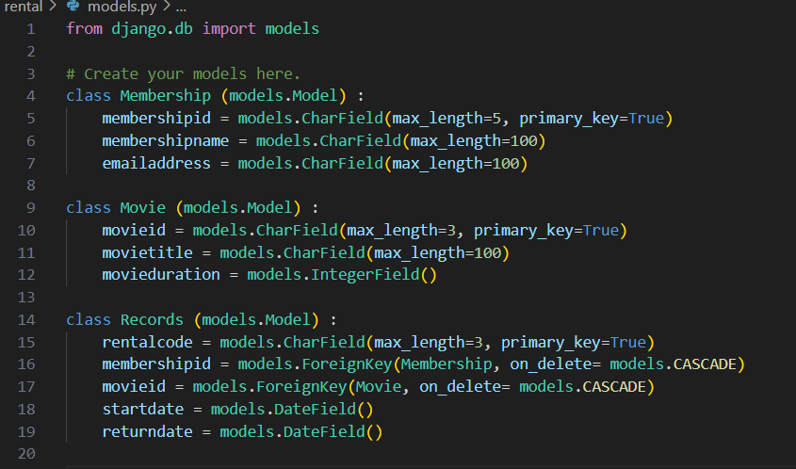Composition/aggregation

**Part C: Apply database operation (Task 6-13)**

* + 1. A screen shot of a computer code

       Description automatically generatedA black screen with white text

       Description automatically generatedA screen shot of a computer

       Description automatically generatedInsert all objects into database.
    2. A computer screen shot of a code

       Description automatically generated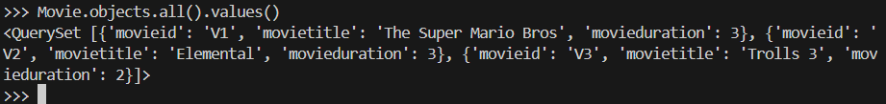A black background with white text

       Description automatically generatedDisplay objects for all classes using command prompt.
    3. A black and white screen with white text

       Description automatically generatedA screen shot of a computer

       Description automatically generatedA screenshot of a computer

       Description automatically generatedDisplay all tables and its objects data using Visual Studio Code.
    4. Terminate interactive console by using appropriate command prompt and provide screenshot.
    5. Add new **field Status** in Membership and set default value to **‘Active’.**
    6. Show updated **objects for Membership.**
    7. Delete **Membershipid=M003.**
    8. Display objects in Records that consists of id movie =1 using command prompt
    9. Display all objects in all tables after executing all tasks until task 12.

### Assessment Rubrics:

| **No.** | **Task** | **Marks** | | **Mark Obtained** |
| --- | --- | --- | --- | --- |
| **Part A** | | | | |
|  |  | * Correct projectname created. | 1 |  |
| 2 | Create a subproject name Rental. | * Successfully an application Rental. | 1 |  |
| * Show correct command prompt used. | 0.5 |  |
| * Provide screenshot for explorer and its files in project using Visual Studio Code. | 1 |  |
| Total (Part A) : | | | | / 3.5 |
| **Part B** | | | | |
| 3 | Add application in settings.py | * Correctly add application in settings.py | 1 |  |
| * Show settings.py yang consists application name. | 0.5 |  |
| 4 | Create class based on tables provided in overview above with appropriate:   1. Class name | * Appropriate class name created. (Each class: 1m, Total: 3m) | 3 |  |
| 1. Properties (data type, maximum number of character) | * Appropriate data type and maximum length for appropriate field. (Each Class: 1m, Max: 4m) | 4 |  |
| 1. Composition/aggregation | * Correctly define key field. (Primary key and Foreign key, Total:4m) | 4 |  |
| Total (Part B) : | | | | / 12.5 |
| **Part C** | | | | |
| 5 | Insert and save data into database. | * Migration is success. (Each table created: 2m, Total: 6m) | 6 |  |
| * Provide screenshot of successful migration in command prompt | 1 |  |
| * Provide screenshot showing fields for all tables in Visual Studio Code Sqlite Explorer. | 1 |  |
| * Able to open interactive console. | 0.5 |  |
| * Successfully create data into table with at least 2 objects. (Each table: 1.5m, Total: 4.5m) | 4.5 |  |
| * Show commands in CLI for opening interactive console and creating data. | 0.5 |  |
| 6 | Display data for all tables using command prompt. | * Show tables containing at least 2 objects using command prompt. (Each table: 0.5, Total:1.5m) | 1.5 |  |
| 7 | Display all tables and its objects data using Visual Studio Code. | * Provide screenshot for all tables containing at least one object using Visual Studio Code (Each table: 0.5, Total:1.5m) | 1.5 |  |
| 8 | Terminate interactive console by using command prompt and provide screenshot. | * Provide screenshot of a successful terminating interactive console by using command prompt. | 1 |  |
| 9 | Add new **field Status** in Membership and set default value to **‘Active’** | * Provide screenshot of codings in models.py | 1 |  |
| * Provide screenshot showing updated field and objects in table using Visual Studio Code. | 1 |  |
| 10 | Show updated **objects for Membership.** | * Provide screenshot of a successful command prompt to update object. | 1.5 |  |
| 11 | Delete **Membershipid=M003.** | * Provide screenshot of a successful command prompt to delete object. | 1 |  |
| 12 | Display objects in Records that consists of id movie=1 using command prompt | * Provide screenshot of a successful command prompt to display all data for the object. | 1 |  |
| 13 | Display data in all tables and its objects after executing all tasks until task 12. | * Provide correct screenshot for all tables and its objects after executing all tasks until task 12. | 1 |  |
| Total (Part C) : | | | | / 24 |
| **Total Marks Earned** | | | | / 40 |
| **Total Percentage (20%)** | | | | / 20 |